**CTF Topic: Finding the Exact Geo-Location of an Image\**

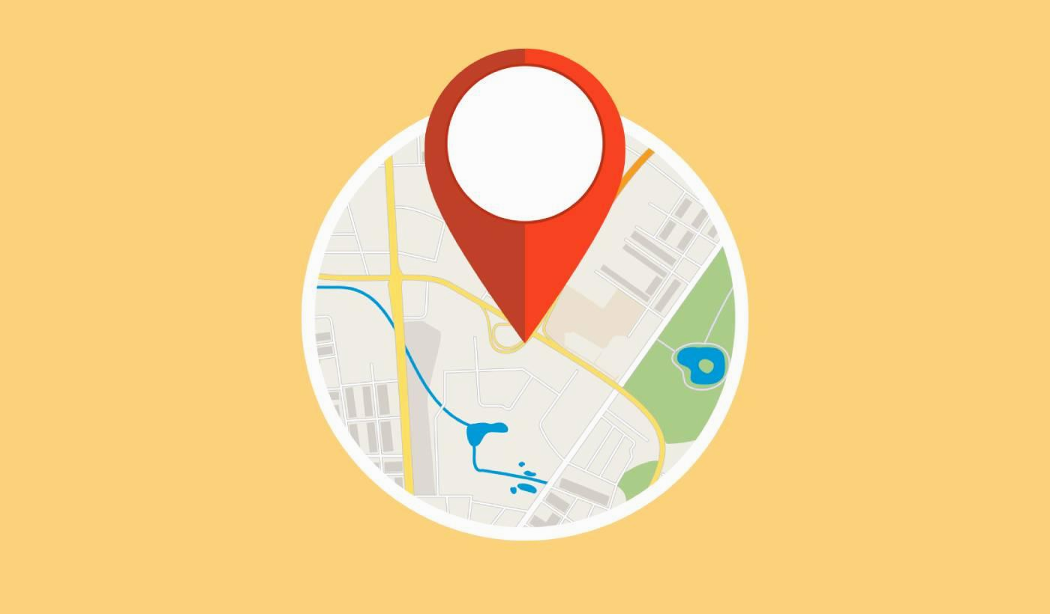

**1. Introduction**

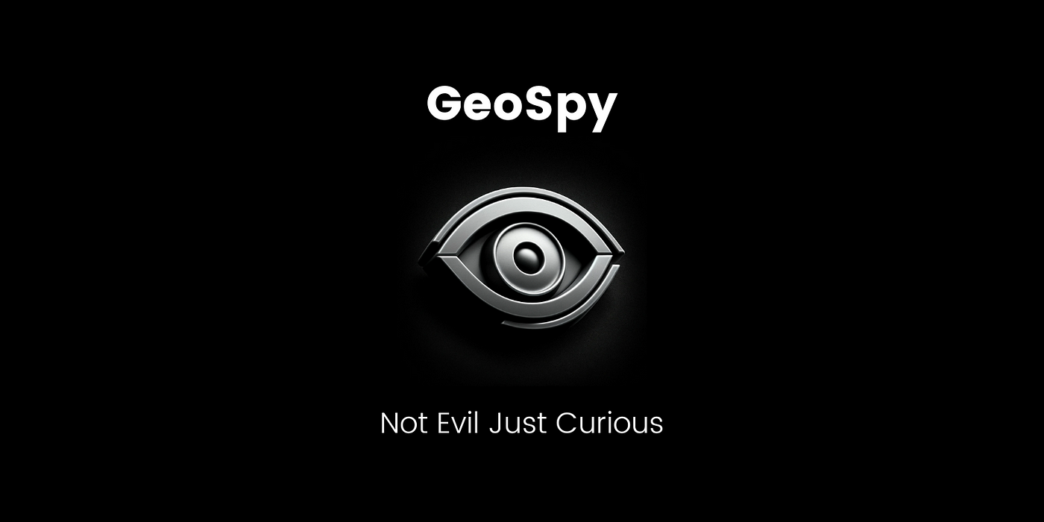

GeoSpy is a web-based tool designed to extract and analyze metadata from images to determine their exact geographical location. This capability is useful for forensic analysis, verifying the authenticity of images, and investigating incidents where location data is crucial.

**2. Tools and Requirements**

Access to GeoSpy:- <https://geospy.ai/>

Access to Image:- <https://ibb.co/NK9X1b6>

**3. Scenario**

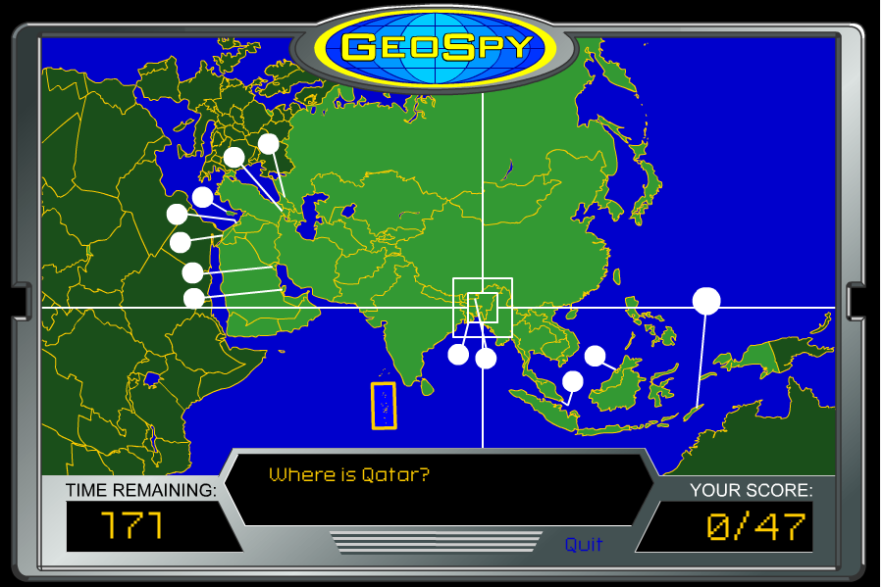

As a cybersecurity beginner, your task is to use GeoSpy to analyze an image and answer questions related to its geographical metadata. This will help you understand how image metadata can reveal location information.

**4. Process to Follow while Performing CTF**

Step 1: Go to your browser and open the provided link:[**https://geospy.ai/**](https://geospy.ai/)

Step 2:Download and upload an image to GeoSpy: <https://ibb.co/NK9X1b6>

Step 3: Right click and do save as to download.

Step 4: And use its features to extract and analyze the metadata. Answer the following questions based on your findings.

Step 4: Solve the CTF

**Questions**

Flag 1: What are the latitude and longitude coordinates extracted from the image?

Answer: Coordinates: 27.9869° N, 86.7065° E

Flag Captured.

Flag 2: What is the name of the city or landmark associated with the extracted coordinates?

Answer: Khumbhu

Flag Captured.

**Hint**

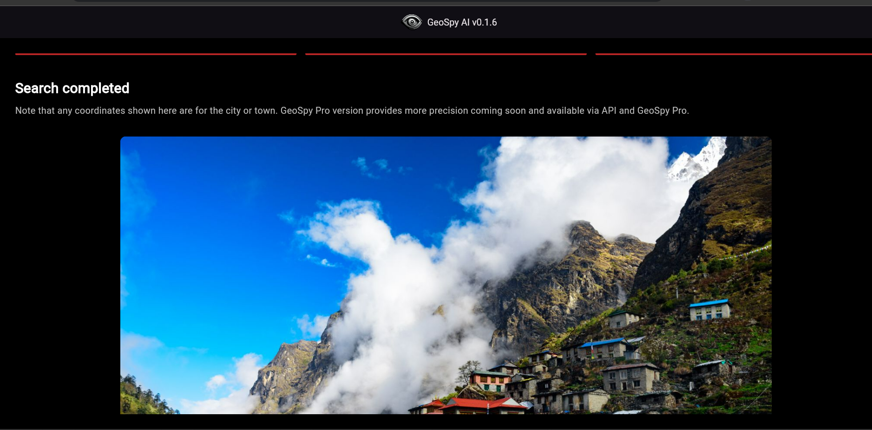

Use GeoSpy to upload and analyze an image, focusing on extracting metadata related to geographical coordinates, date/time, camera model, and other relevant information. Pay attention to the details provided by the tool to answer the questions accurately.

